**PROJECT TITLE: RIDER ANALYSIS USING POWER BI AND SQL SERVER DATABASE**

Time: December 8th, 2024

Tools: Power BI, MS SQL, MS Word

Client: Toman Bike Share

Data: bike_data (provided by client)

Aim:

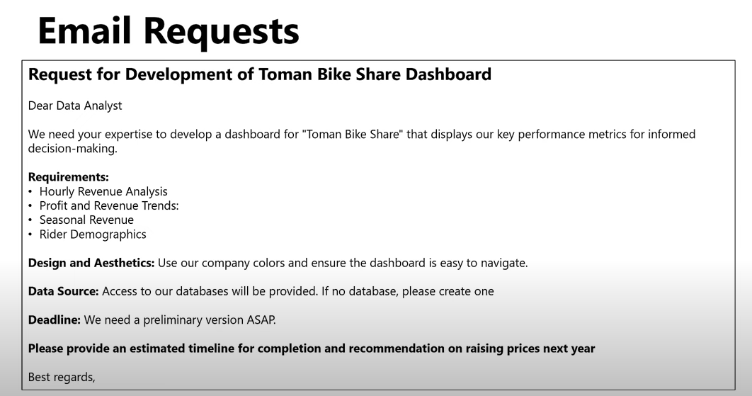

Final Product: an imported database in SSMS and a dashboard in Power BI with insights.

Process:

**Step 1: Importing the Database in SSMS**

* Create a database (bike_data)
* Importing csv files as tables in the database
* Executing SQL scripts to join tables

**Step 2: Integrating the SQL Server Database into Power BI**

**Step 3: Creating Visualizations**

* Connect SQL Server to import data
* Prepare the dashboard canvas
* Create visualizations
* Transform data
* Create new measures and columns
* Optimize the visualizations

**Step 4: Drawing Insights and Conclusions**

**Performance Insights**

Two-Year Analysis (2021-2022):

* Profit Margin: Over the past 2 years, the profit margin has remained below 50%, leaving an area for potential improvement.
* Peak User Participation: The highest user activity is observed between 5:00 PM and 6:00 PM. Introducing strategies to increase participation during morning hours, such as 8:00 AM, could diversify engagement.
* Day-Based Trends: Weekdays, including Sundays, see consistent activity. Fridays and Saturdays exhibit a higher rider count during standard work hours (9:00 AM to 5:00 PM).
* Growth Patterns: Revenue growth has been steady since April 2021, with a significant surge starting in February 2022.
* Seasonal Revenue Performance: The lowest revenue is recorded in Season 1 (0.6M), suggesting a potential focus area for improvement. A majority (81.17%) of riders are registered users, indicating strong customer retention and loyalty.

2022 vs 2021 Comparison:

* Revenue and Profitability: Revenue, profit, and total rider counts saw a significant increase in 2022 compared to 2021. Revenue generated during the least-performing season in 2022 reached $1.6M, nearly matching the highest-performing season of 2021 ($1.7M).
* Seasonal Trends: Busy months occurred between March and November, aligning with periods of higher user engagement.

Proposed Timeline for Completion and Pricing Strategy for Next Year:

Timeline for Completion and Key Objectives:

**January - February:**

1. **Analysis and Planning:**

* Conduct a detailed review of historical data to identify factors driving the significant revenue increase since February 2022.
* Finalize a pricing model for the upcoming year.

1. **Operational Optimization:**

* Implement strategies to improve the profit margin, targeting a gradual increase above 50%.
* Develop targeted campaigns to boost rider activity during morning hours (e.g., 8:00 AM slots).

**March - April:**

1. **Implementation of New Pricing:**

* Introduce a modest price increase, aligning with the demonstrated increase in revenue and rider demand.
* Ensure transparent communication with customers, highlighting the value-added benefits (e.g., improved services or promotions).

1. **Marketing for Busy Months:**

* Launch promotional campaigns to maximize rider participation during the peak months (March–November).

**May - September:**

1. **Monitor and Adjust:**

* Continuously monitor the impact of the new pricing strategy and adjust as necessary to balance demand and profitability.
* Promote incentives for off-peak seasons or low-activity hours to optimize overall rider distribution.

1. **Seasonal Revenue Boost:**

* Focus on initiatives to increase revenue during the historically underperforming Season 1. Consider discounts for early bookings or loyalty programs.

**October - December:**

**Performance Review and Planning:**

* Evaluate the year’s performance in terms of revenue growth, profit margin, and rider engagement.
* Plan further price adjustments, if applicable, for the following year based on performance trends.

Recommended Price Increase for 2025:

**Baseline Increase:**

* Recommend a 5%–8% increase in rider prices, capitalizing on the observed growth in demand and steady user participation.

**Justification and Communication:**

* Highlight service enhancements, customer loyalty rewards, and seasonal discounts to justify the price adjustment.
* Announce changes by February and implement by March to align with peak season preparation.

**Differentiated Pricing:**

* Introduce dynamic pricing based on peak hours (e.g., 5:00 PM–6:00 PM) and busy days (Friday–Saturday), ensuring premium charges for high-demand slots.
* Offer discounted rates for off-peak hours like 8:00 AM to encourage morning riders.